**Group Service-Learning Project Ideas**

* Case for Smiles

<https://caseforsmiles.org/>

<https://caseforsmiles.org/northern-nevada/>

Sewing colorful pillowcases for children with cancer

* Room to Read

<https://www.roomtoread.org/>

Students can hold book drives and read-a-thons to raise money/donate to children

* Soles4souls

<https://soles4souls.org/>

Hold a walk-a-thon, shoe drive, or a Kick off your shows “dance-a-thon” for children in need

Homeless shelters in the area: hold a drive for toiletries or make laminated place mats for the shelters that serve food. Work on drives for toys or books for homeless children and youth.

* Environment: Use the Lorax to think about planting trees or other plants around the campus or area, gardening, etc.
* Decorated rocks: have students decorate and paint small rocks designed to brighten up others’ days. These can be hidden around Wooster or the local area where other students and community members might find them.
* Kids Crafts: Make kits full of craft supplies or projects for the children at Renown Children’s Hospital
* No-sew fleece blankets for homeless
* Organize food drive
* Cleanup around campus: This can include projects like painting, planting/gardening, cleanup, and other projects the students might want to undertake.
* Adopt the Colt’s Closet (where students in need can get food, toiletries, clothes, etc.)—Work with Ms. Danielson to clean/organize and help recruit for donations

**Individual Service-Learning Opportunities**

<https://nevadavolunteers.org/>

Nevada Humane Society

[www.nevadahumanesociety.org](http://www.nevadahumanesociety.org)

Requirements

* Fill out a volunteer application/profile
* 10 years of age or older
  + Those under 16 must be accompanied by a parent/guardian who is 18 and older
* Volunteers 16-years or older need to attend a one hour volunteer orientation
* Minimum time commitment: 15 hours in the first 6 months
* Opportunities: Cat Socialization and Enrichment, Dog Socialization and Enrichment (18 and older only), Small Animal Socialization and Enrichment, Shelter Greeter, Administrative, Adoption Follow-Up Calls, Pet Food Assistance, General Shelter Activities, Pets on Tour, Special Events, Trap-Neuter-Return, Foster Care, and Hiking Buddies
* Hours available: Generally, Monday-Sunday, 11am to 6pm.
* Meals on Wheels

7 Learning Objectives

1. Awareness of your strengths and developing weaknesses
2. Developing international-mindedness and global understandings
3. Learning Perseverance over challenge
4. Collaborating with others
5. Contemplating an ethical issue
6. Taking initiative
7. Learning new skills

|  |  |  |  |
| --- | --- | --- | --- |
| **Organization** | **Activity** | **Contact** | **Notes** |
| Note-Able | Music Therapy | 775-324-5521  [NOTE-ABLE MUSIC THERAPY SERVICES RENO (nmtsreno.org)](https://www.nmtsreno.org/) | [RSVP 2 — NOTE-ABLE MUSIC THERAPY SERVICES RENO (nmtsreno.org)](https://www.nmtsreno.org/volunteer) |
| Great Basin Institute | Research Associate Program | [www.theGreatBasinInstitute.org](http://www.theGreatBasinInstitute.org) |  |
| Project Sweet Dreams | Pajama Drive | [www.projectsweetdreamsnv.com](http://www.projectsweetdreamsnv.com)  775-386-2333  [Project Sweet Dreams | Contact (projectsweetdreamsnv.com)](http://projectsweetdreamsnv.com/contact/) |  |
| The Rotary Club of Reno Central |  | [www.renocentralrotary.com](http://www.renocentralrotary.com) |  |
| Tu Casa Latina |  | [www.tucasalatina.org](http://www.tucasalatina.org)  775-432-9929 |  |
| NYEP: Nevada Youth Empowerment Project |  | [Nevada Youth Empowerment Project (NYEP) – Guiding young women from poverty to opportunity](https://nyep.org/)  775-747-2073 |  |
| Immunize Nevada | Welcomes volunteers under 18 to assist with public health initiatives, including vaccination awareness and community outreach. | <https://immunizenevada.org/volunteer> |  |
| Girls on the Run |  | 775-298-0283  [www.girlsontherun.org](http://www.girlsontherun.org) | Help training/running training sessions for students: Junior Coaching—10-week commitment for 1 day a week for 90 minutes. Help girls in 3rd-5th grade and work with a coaching team to lead and implement lessons |
| Boys & Girls Club of Truckee Meadows | Offers roles for high school students, including self-motivated volunteers and those fulfilling community service requirements. Opportunities range from mentoring to assisting with youth programs. |  |  |
| Police Jr. Cadets | The Washoe County School Police Jr. Cadet Class is open to all High School students registered in Washoe County School District.   Students in the class program can learn about Law Enforcement and earn high school credit at the same time. |  |  |
| Reno Bike Project |  | [jillian@renobikeproject.org](mailto:jillian@renobikeproject.org)  775 323 4488, or visit the RBP shop at 216 E. Grove St. |  |
| Renown Medical Center | Interested in a career in medicine? Volunteering at Renown is a great way to give back and expose yourself to what it is like to work in medicine. | https://www.renown.org/about/volunteers/ |  |
| American Red Cross | As a Red Cross volunteer, you can help people displaced by disaster or go into schools and show children how to prepare for a fire. You can teach CPR and First Aid or go out into the community spreading the Red Cross mission. Most of all, Red Cross volunteers help save lives and what could be more fulfilling than that? | https://www.redcross.org/local/nevada/volunteer.html |  |
| Discovery Museum | Discovery has a very active team of volunteers who contribute their time and talents to support the museum’s educational mission. Volunteers gain new skills and experiences, meet interesting people and make a tremendous impact on The Discovery’s visitors. | <https://nvdm.org/support/volunteer-at-the-discovery/> |  |
| Volunteer Match Reno | An online platform listing various local volunteer opportunities, with filters to find teen-friendly positions | <https://www.washoeschools.net/Page/11158?utm_source=chatgpt.com> |  |
| Washoe County Library Volunteen Program | A virtual volunteer program allowing teens to earn up to 20 hours by promoting library resources and services online. | <https://www.washoecountylibrary.us/teens/volunteen.php?utm_source=chatgpt.com> |  |
| Food Bank of Northern Nevada | Whether you are a self-motivated individual volunteer, represent a community or employee group, or are looking for school or work-related, or court-ordered community service opportunities, there’s something for you to do to help at the Food Bank of Northern Nevada | <https://fbnn.org/get-involved/volunteer/> |  |
| Achieve Tahoe Team | Join the Achieve Tahoe team to help provide access to outdoor recreation that builds health, confidence, and independence in people with disabilities | <https://www.achievetahoe.org/volunteer/volunteer-opportunities/> |  |
| City of Reno Youth City Council | A platform for teens aged 14–22 to engage in civic activities, plan youth events, and advise the Reno City Council on youth-related issues. |  |  |
| Washoe County School District |  | Dex Thomas  775-348-0222  [dlthomas@washoeschools.net](mailto:dlthomas@washoeschools.net) |  |
| Opportunity Alliance Nevada |  | [Nevada Financial Resiliency & Empowerment Project (NFREP) – To build financial stability for all Nevadans (opportunityalliancenv.org)](https://opportunityalliancenv.org/) |  |
| Girl Scouts of the Sierra Nevada | Junior leader, other volunteer opportunities | [Girl Scouts Sierra Nevada (gssn.org)](https://www.gssn.org/) |  |
| Just Serve |  | [JustServe](https://www.justserve.org/) |  |
| WCSD Volunteer Opportunities |  | [Volunteer Services / Volunteer Opportunities (washoeschools.net)](https://www.washoeschools.net/Page/678) |  |
| Nevada Urban Indians |  | [www.nevadaurbanindians.org](http://www.nevadaurbanindians.org)  775-788-7600 |  |
| R.A.V.E. | Babysitting foster kids at their facility | [(nnrff.org)](https://nnrff.org/) |  |
| Wishes & Angels of No. Nevada | Help to do drives or volunteer for “experiences” (Valentine’s Day, Easter, Prom, Graduation, Birthday, Halloween, Thanksgiving, Christmas) | 775-980-5383  [Wishes.and.angels.nn@gmail.com](mailto:Wishes.and.angels.nn@gmail.com)  www.facebook.com/groups/WishesAngelsNorthern Nevada |  |
| Reno Little Theater |  | 775-813-8900  www.Renolittletheater.org |  |
| Crisis Call Center |  | 775-784-8085  [volunteer@crisiscallcenter.org](mailto:volunteer@crisiscallcenter.org)  http://crisiscallcenter.org |  |
| Big Brothers Big Sisters of Northern Nevada | Help with clothing or item drives (they will pick up items and then they sell it to Savers to raise money), volunteer at other events like their fall carnival fundraiser | [Home - Big Brothers Big Sisters of Northern Nevada - Youth Mentoring (bbbsnn.org)](http://www.bbbsnn.org/) |  |
| Volunteers of America |  | 775-322-7143  voa-ncnn.org |  |
| Lexie’s Gift |  | 775-745-2184 |  |



What: Aid Station, Face Painting, Happy Hair, Inspiration Station. For those over 16: Course Marshal, Photo Booth

When: November 5th

Contact: [www.girlsontherunsierras.org](http://www.girlsontherunsierras.org)

[Courtney.vogt@girlsonthe](mailto:Courtney.vogt@girlsonthe)run.org

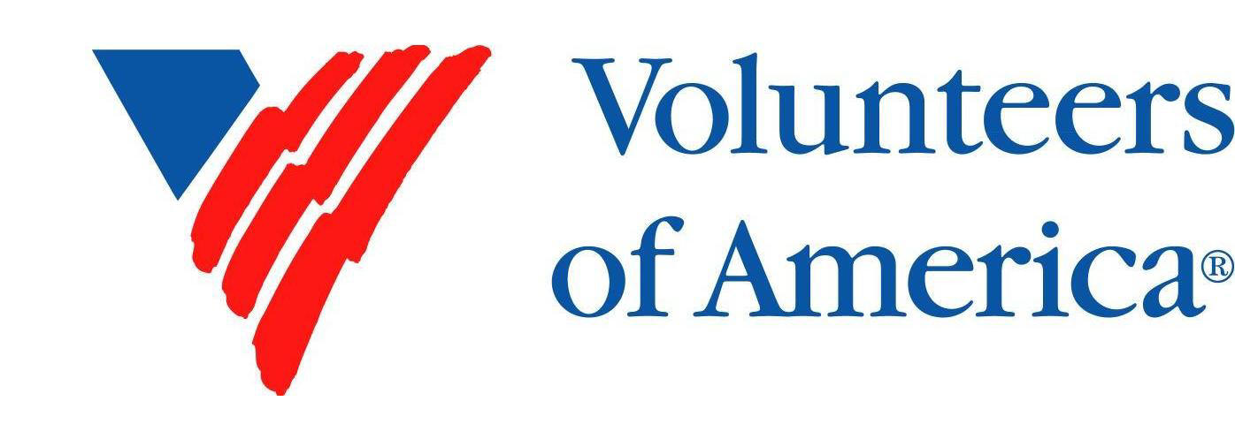

What: Plan a special activity such as a craft night, game night, or holiday party

Contact: Denise Walters, [denisewalters.voa@gmail.com](mailto:denisewalters.voa@gmail.com)

OR  
What: ReStart Programs—clerical assistance (filing, excel spreadsheets, etc.), help staff at the Resource Center, hold fundraising event or collection drive (toiletries, blankets and winter gear, backpacks and luggage, household supplies)

Contact: [www.voa-ncnn.org](http://www.voa-ncnn.org) or [lgrace@voa-ncnn.org](mailto:lgrace@voa-ncnn.org)

**STUDENT NOTES**

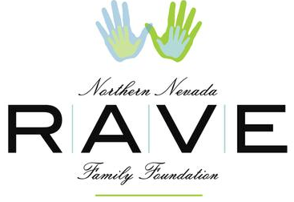

What: RAVE—working with children in Foster Care

When: Tuesdays, Wednesdays, and Thursdays from 5pm-9pm or Saturdays from 9:30-1:30

Contact: www.nnrff.org

ravefamilies@att.net or 775-787-3520

How: Contact Betsy Aguiar. Fill out a volunteer application.



What: Classroom or Event volunteers (dancing and music)

Contact: 775-324-5521 or [mail@note-ables.org](mailto:mail@note-ables.org)

www.note-ables.org